- Full Name- Poonam Langote
- Assignment Number and Name- Task6-: Create an S3 Bucket, Apply Policy, and Host a Static Website
- Submission Date- 30/03/2026
- AWS Region used- us-east-1
=================================================Steps
Go to S3 -> Create Bucket.
Name: static-site-[yourname]
Region: us-east-1
Uncheck Block all public access.
Acknowledge the warning.
Create the bucket.
Create a local file named index.html with the following content:
<html>
<body>
<h1>My AWS S3 Website</h1>
<p>Hosted on Amazon S3 by [YourName]</p>
</body>
</html>
Upload index.html to the S3 bucket.
Go to Properties -> Static Website Hosting -> Enable.
Index document: index.html
Save.
Go to Permissions - Bucket Policy and paste:
"Version": "2012-10-17",
"Statement": K
"Effect": "Allow",
"Principal": "*",
"Action": "s3:GetObject",
"Resource": "arn:aws:s3 ::: static-site-[yourname]/*"
}]
}
Save the policy.
Copy the Website endpoint URL from Properties.
Open it in a browser - the page should load.
Create and upload a second file about.html with different content.
Visit: http://your-endpoint/about.html
Confirm it is publicly accessible.

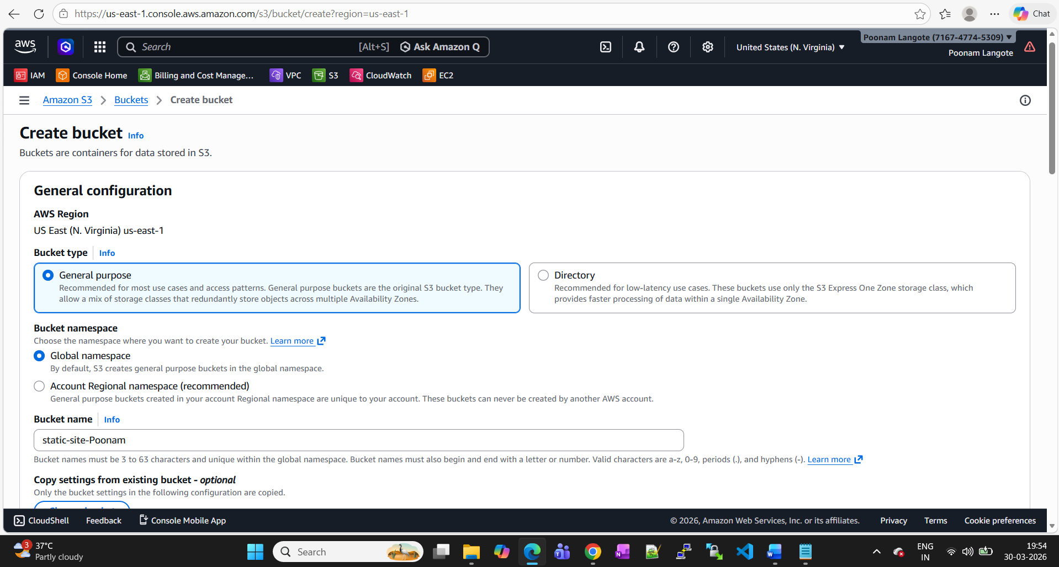

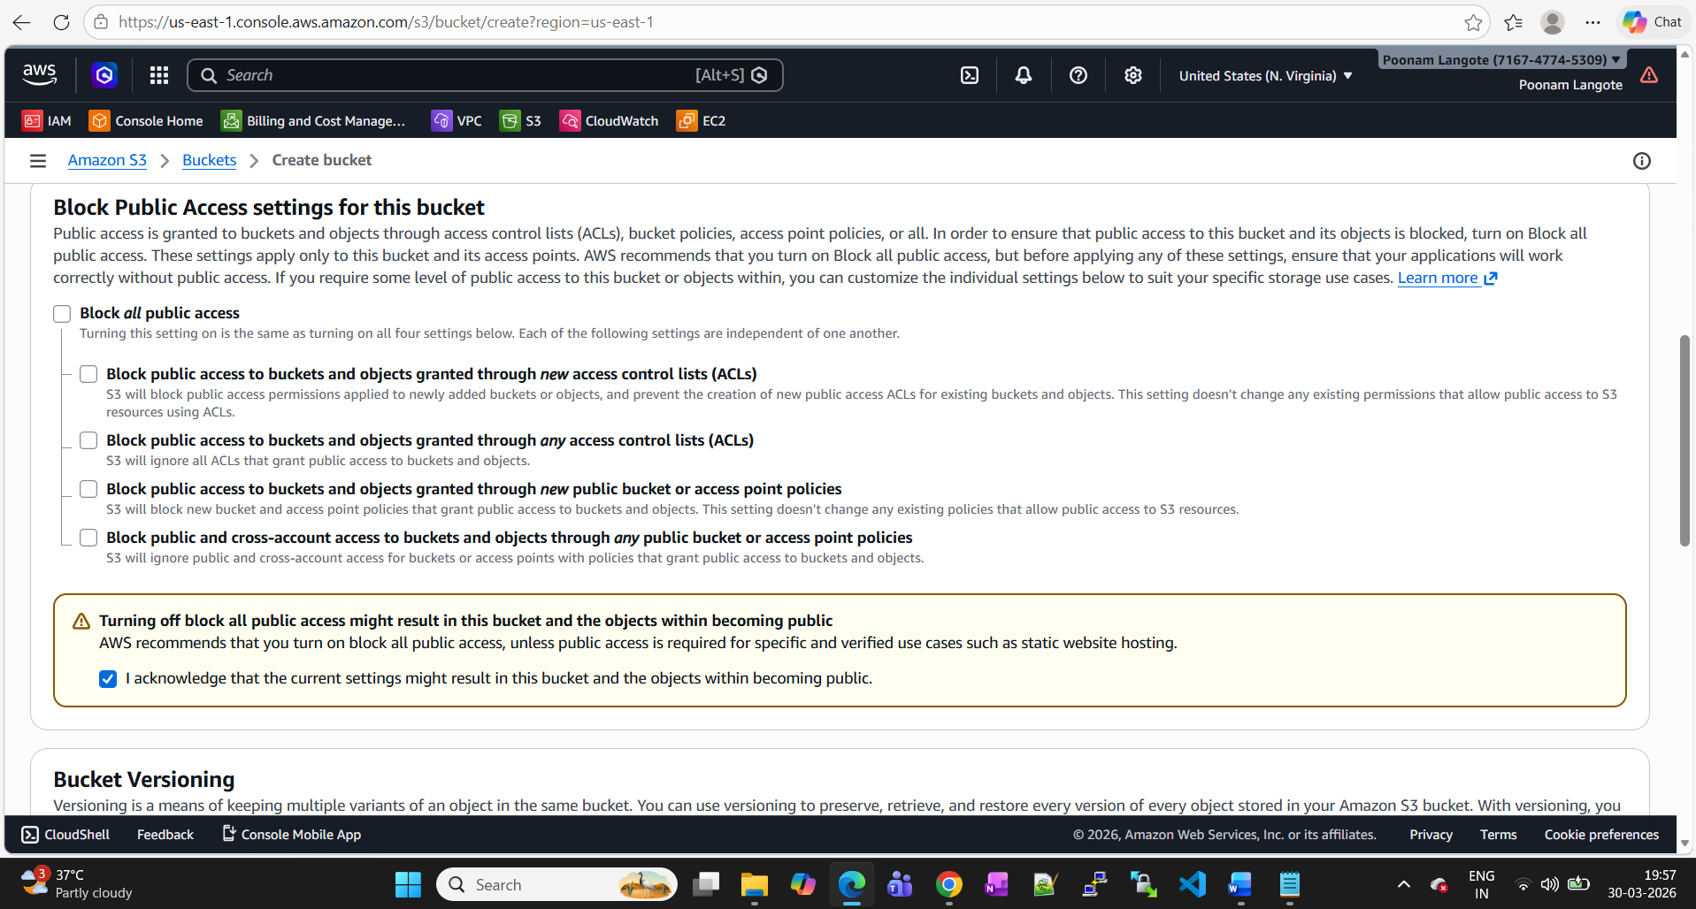

Bucket created & index.html file uploaded to s3 bucket (static-site-poonam)

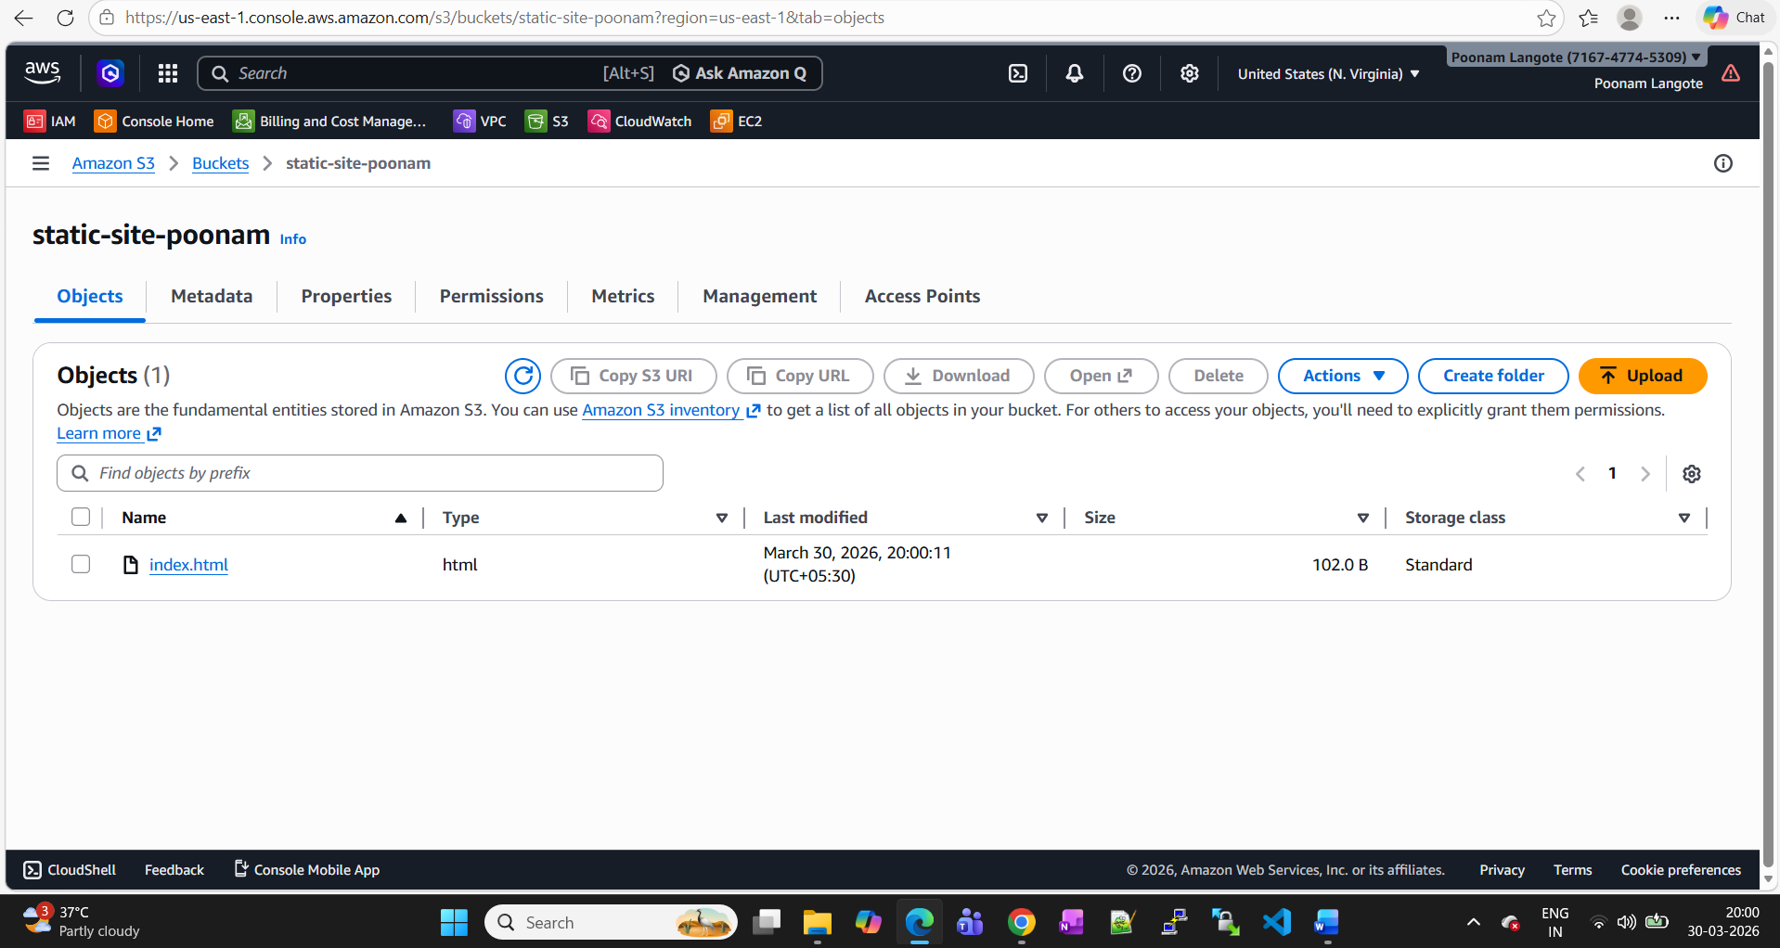

Bucket Policy-
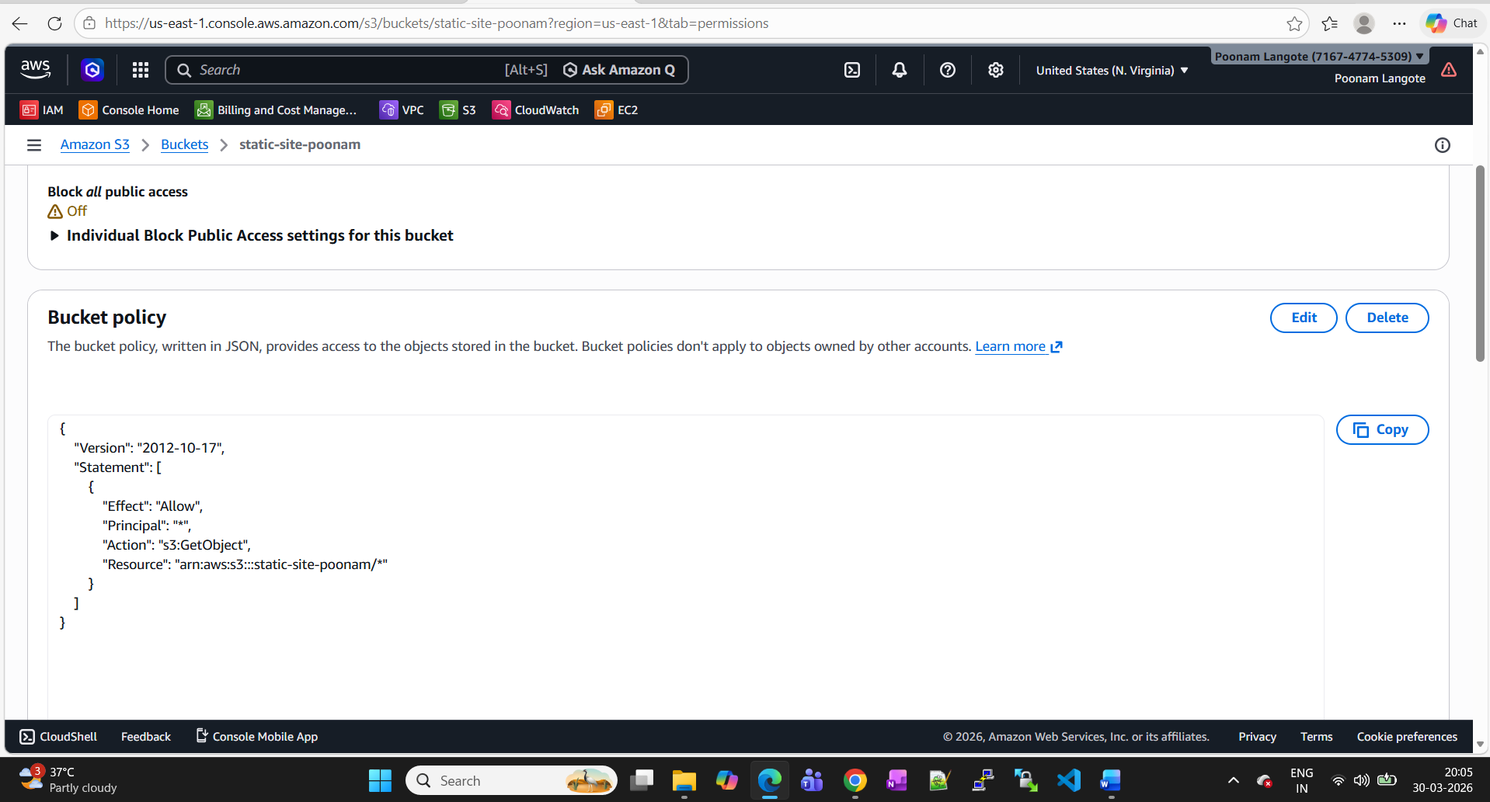

Static web hosting enabled.
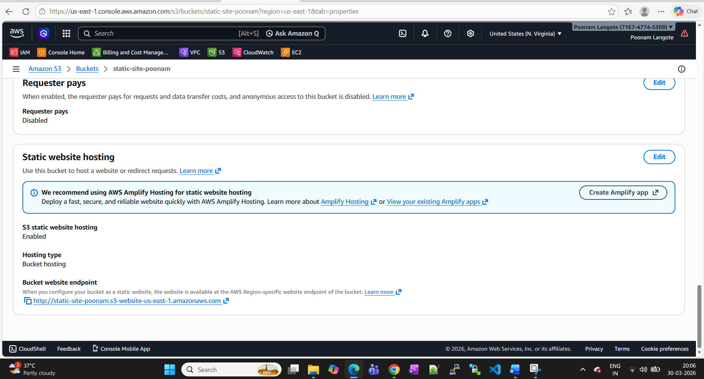

Endpoint URL- http://static-site-poonam.s3-website-us-east-1.amazonaws.com

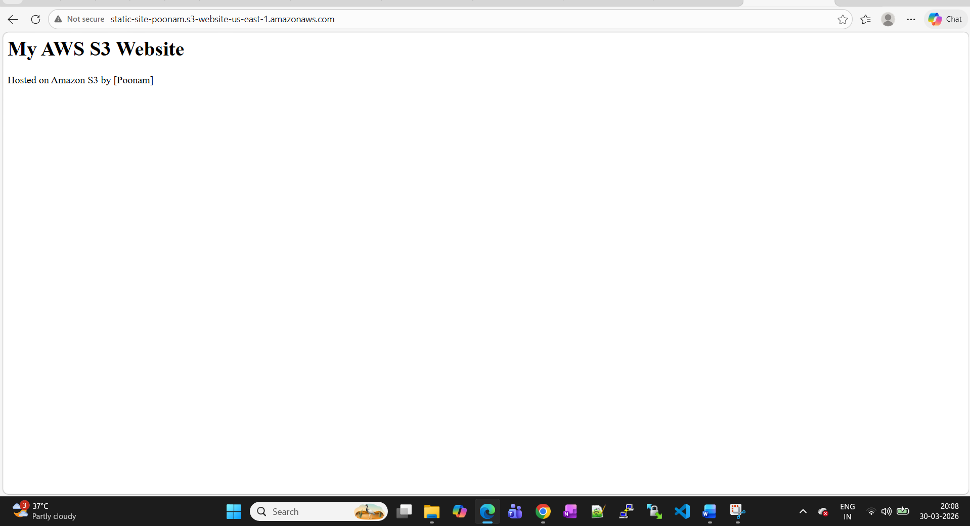
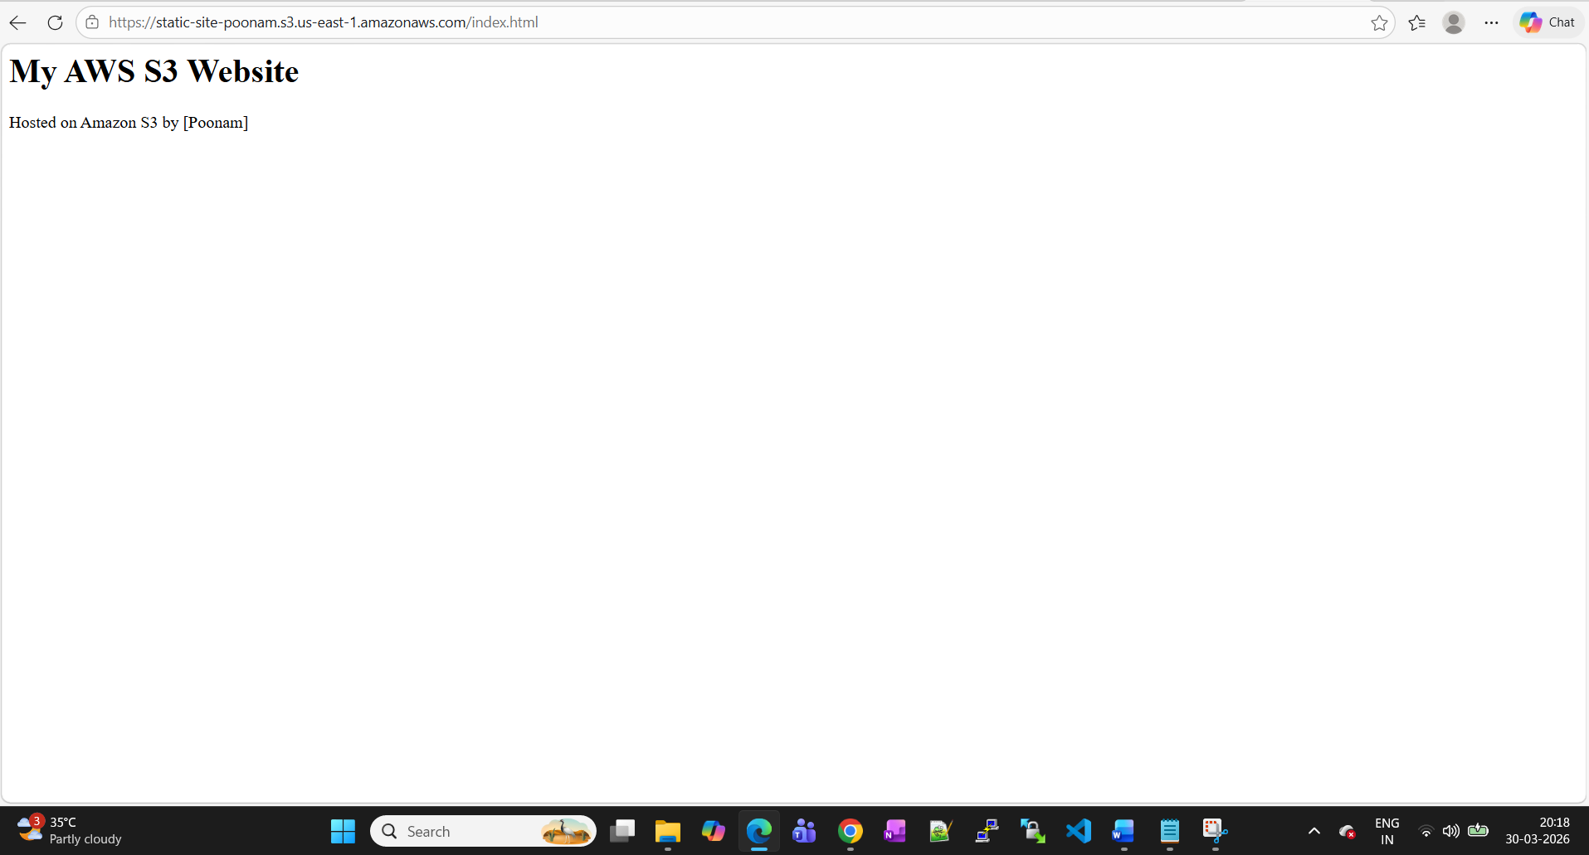

about.html file uploaded to bucket.

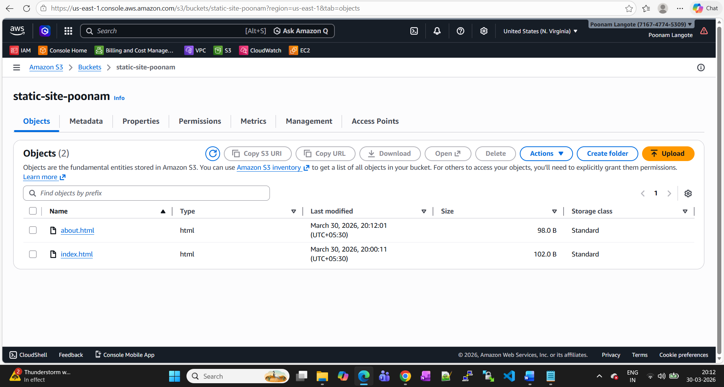

Access URL-
https://static-site-poonam.s3.us-east-1.amazonaws.com/about.html
